

# Placement Empowerment Program

***Cloud Computing and DevOps Centre***

To Set Up a Cloud-Based Monitoring Service

Name:Kowshica N Department: Biotech



# Introduction

Cloud-based monitoring services, such as AWS CloudWatch, provide a centralized platform to monitor, manage, and gain insights into the performance and health of cloud resources. These services are critical for ensuring the optimal functioning of cloud-based virtual machines (VMs) and applications. By collecting metrics like CPU utilization, disk I/O, memory usage, and network activity, administrators can maintain system performance, troubleshoot issues, and optimize resource usage.

# Overview

Cloud monitoring tools like AWS CloudWatch offer the following functionalities:

1. **Metrics Monitoring**: Tracks resources like CPU usage, memory, disk I/O, and network throughput.
2. **Alarms**: Notifies users of unusual activity or threshold breaches.
3. **Logging**: Centralized collection of logs for system events, errors, or custom application logging.
4. **Dashboards**: Visualize metrics using graphs and charts for a comprehensive overview.
5. **Event Management**: Automatically trigger actions (e.g., scaling resources) based on conditions.

# Objectives

The primary objective of setting up a cloud-based monitoring service is to enable real-time monitoring of cloud infrastructure to:

* Identify performance bottlenecks.
* Detect and respond to system anomalies.
* Ensure resource usage remains cost-effective.
* Enable automated responses to predefined conditions

# Importance of Hosting with GitHub Pages

• **Improved System Health**: Continuous monitoring reduces the likelihood of downtime.

• **Proactive Issue Resolution**: Early alerts allow teams to resolve problems before they escalate.

• **Cost Efficiency**: Helps identify underutilized or over-provisioned resources.

• **Scalability**: Automatically adjusts resources based on demand.

• **Compliance**: Ensures that the system adheres to regulatory or operational requirements.

#### Step 1: **Set Up the Monitoring Service**

* **AWS** 
  1. Log in to the AWS Management Console.
  2. Navigate to **CloudWatch** under the "Management & Governance" section.
  3. Enable detailed monitoring for your VM instances (optional for more granular data).

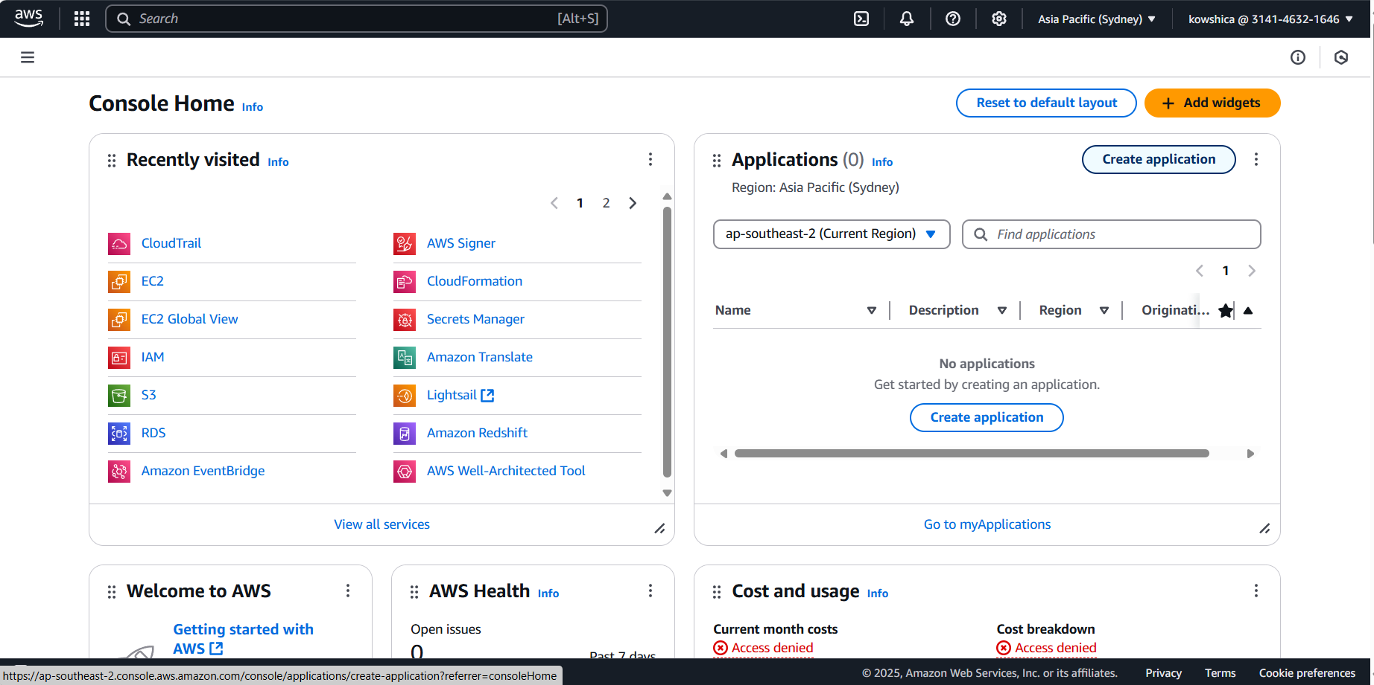

Step 2:

**Configure Metrics Collection**

* By default, CloudWatch collects basic metrics like CPU usage, disk reads/writes, and network activity.
* For custom metrics:
  + Use the **AWS CLI** or **SDK** to publish application-specific metrics.

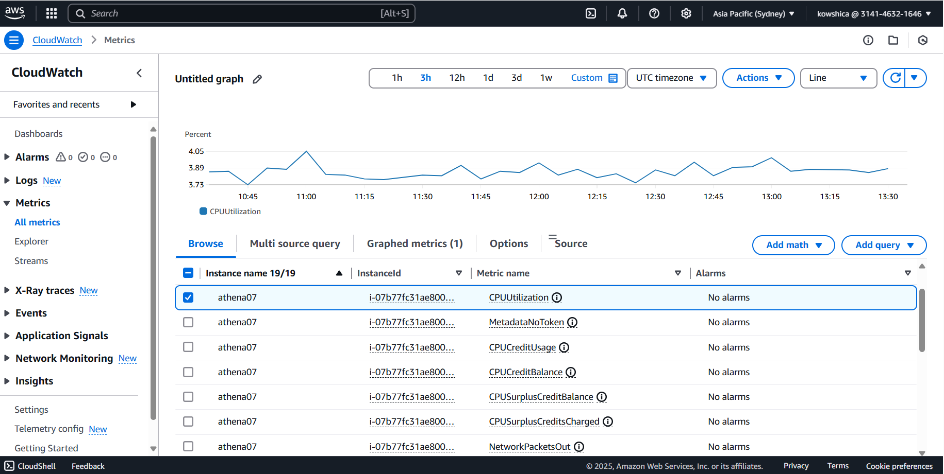

#### Step 3: **Set Up Alarms**

* Navigate to the "Alarms" section in CloudWatch.
* Create a new alarm:
  1. Select a metric (e.g., CPUUtilization).
  2. Define the threshold (e.g., greater than 80%).
  3. Configure notification settings (e.g., email or SMS via Amazon Simple Notification Service - SNS).



Step 4:

**Enable Logging**

* Use the **CloudWatch Logs** feature to collect application and system logs:
  + Install and configure the **CloudWatch Agent** on your VM.

Use **CloudWatch Dashboards** to create custom visualizations:

1. Navigate to the "Dashboards" section.
2. Create a new dashboard and add widgets to display key metrics.

Configure **CloudWatch Events** or **Auto Scaling** to respond to metric changes (e.g., scale up instances when CPU usage exceeds 70%).



Outcome

• **Enhanced System Visibility**: Real-time insights into resource performance and health.

• **Improved Operational Efficiency**: Automation of repetitive tasks and issue resolution.

• **Optimized Costs**: Effective allocation and scaling of resources.

• **Minimized Downtime**: Early detection and prevention of system issues.

• **Scalable Monitoring Framework**: Seamlessly adapts as infrastructure grows.